**MINUTES OF THE THEBERTON AND EASTBRIDGE PARISH COUNCIL MEETING HELD   
AT THE JUBILEE HALL, THEBERTON ON WEDNESDAY 8th JANUARY 2020 AT 7:30 PM**

1. **Attendance and Apologies**

|  |  |
| --- | --- |
| **Attendees:** Cllr. Stephen Brett - Chair Cllr. Hilary Ward - Vice Chair Cllr. Paul Collins Cllr. Nat Bacon  Cllr. Stephen Morphey  Cllr. Philip Baskett Cllr. Julian Wallis Cllr. Graham Bickers | **Apologies for absence:** Cllr. Beth Goose - written and accepted  District Cllr. Terry-Jill Haworth-Culf District Cllr. Tony Cooper  **In attendance:**  County Cllr. Richard Smith  District Cllr. Jocelyn Bond  Sharon Smith - Clerk/RFO |

1. **Declarations of Pecuniary and Non-Pecuniary Interests**

Cllr. Philip Baskett declared an interest in item 8a.

1. **Public Forum**

District Cllr. Jocelyn Bond summarised salient points from her previously circulated report. She also reported on the recent Strategic Planning Committee meeting which considered the District Council’s response to the SPR application to the Planning Inspectorate for the EAN1 and EA2 offshore windfarms with an onshore substation at Friston. The Deputy Leader, Cllr. Craig Rivett, has delegated responsibility to draft the response. Cllr. Tony Cooper will be an unofficial sounding board and will attend all energy company briefings where he can provide input into the response from a local perspective. Cllr. Stephen Brett raised a concern that Cllr. Craig Rivett was not from the Suffolk Coastal area and has not been involved with any of the energy projects before become Deputy Leader; therefore he may not be aware of all the issues from a local perspective.  
ACTION: Clerk to invite Cllr. James Mallinder, the Cabinet member with responsibility for the Environment, to attend the next meeting.

**4.** **Minutes**

It was proposed by Cllr. Hilary Ward, seconded by Cllr. Philip Baskett, and agreed that the minutes for the meeting of 11th December 2019 be signed as a true record.

**5. Matters Arising**

a) Following his inspection of the shed at the burial ground, Cllr. Graham Bickers recommended that it is repaired and made safe. Cllr. Stephen Brett proposed that up to £100 is authorised for expenditure on materials. Seconded by Cllr. Graham Bickers. All in favour.  
ACTION: Cllr. Graham Bickers, Cllr. Stephen Brett and Cllr. Stephen Morphey to expedite repairs.

b) The Clerk reported that numerous fraudulent direct debit transactions have occurred on both bank accounts over the past six months. Reporting and reversing these transactions is taking up a considerable amount of the Clerk’s time. It was agreed to write a letter of complaint to Barclays Bank and to ask for monetary compensation for the Clerk’s time.  
ACTION: Clerk to progress.

**6. Public Forum Resumed**

County Cllr. Richard Smith apologised for being late due to his attendance at another meeting. The County Council has been catching up on the backlog of meetings which were postponed due to the general election. The Scrutiny Committee have examined next financial year’s budget. The Cabinet will now consider the budget with the final decision being published in February.

Cllr. Graham Bickers raised the poor condition of the resurfaced roads in the parish. The new surface, which should last 10 years, is already beginning to lift as the tarmac was laid on top of compacted mud. Cllr. Smith advised the Council to report this matter online to Highways with photographs and exact locations.  
ACTION: Cllr. Nat Bacon to progress.

Cllr. Smith apologised for not attending the recent Sizewell C Community Forum as he was not informed about it. Cllr. Stephen Brett informed the Council that he and Cllr. Roy Dowding from Middleton cum Fordley Parish Council complained to the Sizewell C Community Forum Secretariat as their questions about the relocation of Sizewell B facilities to make way for the development of Sizewell C were not accepted.

Cllr. Graham Bickers asked Cllr. Smith if the County’s large Town Councils were also expected to undertake Community Self-Help to clean road signs and cut verges as the smaller parishes had been asked to do. Cllr. Smith replied that there was no obligation to undertake this work and that both Town and Parish Councils had been offered Highways support in the form of equipment, training and insurance cover.

**7. Councillors’ Meetings and Progress Reports**

a) Theberton Playing Field Improvements -

i) Cllr. Hilary Ward reported that the Clerk has had to apply for planning permission for the play equipment. The application for funding from the ESC Outdoor Playing Space Fund is out for consultation with the Ward Members and neighbouring Parish Councils until the end of January.

ii) Cllr. Stephen Brett reported that a resident has offered £200 towards the planting of a hedgerow. The Clerk advised that further funding may be applied for from the Sustainable Development Fund administered by the Suffolk Coasts and Heaths AONB.   
ACTION: Cllr. Nat Bacon to measure the area and to obtain quotes for whips and covers. Clerk to begin completing the grant application form.

b) Eastbridge Speed Limit - the Council agreed to budget for the Highways speed survey next financial year and to request that this is conducted during the busier summer months.

c) Sizewell Matters -

i) Cllr. Paul Collins reported that it has been a relatively quiet month. EDF Energy are now expected to submit their application for a Development Consent Order in the first half of 2020, not the first quarter as previously advised. Paul Morton, who was the Director of Sizewell B, has taken over as head of the Sizewell C project. TEAGS are scheduled to meet Richard Rout, a County Council cabinet member with responsibility for Sizewell C.

ii) With regard to raising the complaint against East Suffolk Council to the second stage, the Council approved the previously circulated letter drafted by Cllr. Paul Collins and Cllr. Graham Bickers with minor amendments.  
ACTION: Clerk to submit the final version.

iii) The Council agreed to register with the Planning Inspectorate and to make a representation regarding the application for consent by Scottish Power Renewable for the East Anglia One North and Two offshore windfarms.   
ACTION: Cllr. Paul Collins to draft a response referring to the cumulative impact of the various energy projects on the B1122 and submit online.

iv) Cllr. Stephen Brett reported that he had spoken to TASC member Joan Girling about the group’s request for a judicial review into ESC’s decision to allow the relocation of Sizewell B facilities. The project and the crowdfunding campaign are progressing well.

d) Speed Indicator Device - report attached as Appendix I.

e) Police - no crimes were reported in November 2019.

f) Jubilee Hall - the Clerk circulated a quotation from BT for the installation and ongoing costs for a landline and broadband. Cllr. Nat Bacon agreed to contact BT to negotiate a more favourable monthly fee. The Council agreed, in principle, to proceed and to submit the revised quotation to the District Councillors who had previously agreed to meet the installation and first year costs.  
ACTION: Cllr. Nat Bacon to progress.

**8. Parish Matters**

a) Cllr. Graham Bickers proposed to support planning application DC/19/4813/FUL- conversion of an old council depot/storage building into a one bedroom holiday let/living accommodation. With two extra holiday lodges and a new driveway access into the site from Pretty Road/Land South of Pretty Road. Cllr. Stephen Brett seconded. All in favour. Cllr. Philip Baskett, who previously declared an interest, left the room and took no part in the voting.

b) The Council decided not to initiate a Community Energy Scheme at this time.

c) The Council reviewed and updated the Outstanding Actions list.

**9. Finance**

a)The Council noted the latest financial position detailed in Appendix II.

b) The Council reviewed the budgeted versus actual expenditure for Q3 2019-2020.

c) The Council approved the budget for the financial year 2020/2021.

d) Following a discussion, the Council agreed to increase the parish precept to £6,916.08, which is a 15% increase on the current year’s precept. The increase is necessary to meet expected expenditure over the next financial year and to avoid drawing down on the Council’s reserves.  
ACTION: Clerk to request precept from East Suffolk Council and upload the budget to the website.

e) It was proposed by Cllr. Stephen Brett, seconded by Cllr. Hilary Ward, and agreed to authorise the payments listed below. All in favour.

|  |  |  |  |
| --- | --- | --- | --- |
| **Details** | **Payee** | **Amount** | **Power** |
| Clerk’s Salary | Sharon Smith | £226.78 | LGA 1972 s.111 |

**10. Correspondence**

The Council noted the correspondence received between 6th December 2019 and 2nd January 2020 detailed in Appendix III.

**11. Questions to the Chair**

Cllr. Julian Wallis asked for an update on the status of the redundant telephone kiosk at Eastbridge which has now been vandalised. The Clerk advised that the kiosk was adopted by the Community Heartbeat Trust who had previously been asked to instruct BT to remove it.  
ACTION: Clerk to follow up.

**12. Date and Time of Next Meeting**

The Council confirmed the date and time of the next meeting of the Council which is scheduled for Wednesday 12th February 2020 at 7:30 pm.

The meeting closed at 9:20 pm.

**Appendix I - Financial Position**

|  |  |
| --- | --- |
| **Bank Balances as at 12th December 2019** |  |
| Barclays Current Account | £4,803.39 |
| Barclays Savings Account | £1,516.00 |
|  | **£6,319.39** |
|  |  |
| **General and Earmarked Reserves** |  |
| EDF Energy Grant - Work Party Tools | £132.58 |
| General Reserves | £2,495.00 |
| Parish Playing Areas Maintenance and Sinking Fund | £1,000.00 |
|  | **£3,627.58** |
|  |  |
| **Bank Balance less Reserves** | **£2,691.81** |
|  |  |
| **Payments - January 2020** |  |
| Sharon Smith - Clerk’s Salary | **£226.78** |
|  |  |
| **Net Balance** | **£2,465.03** |

**Appendix II - Speed Indicator Device**

**Theberton Speed Indicator Device Report 8 January 2020**

The speed indicator device has been operational for thirty-seven ~20-day periods since 20th December 2016. It is placed at one end of the village or other at ~30 day intervals.

For the 4 months in 2019 the SID was placed at each end of the village but turned around to watch the traffic leaving the village. There is a drop in the number of vehicle movements which is due to the SID being having its radar blocked by cars on its nearside.

The last eight 20 day periods has seen the SID turned once again to face traffic coming into the village and traffic volumes and speeds have returned to similar averages seen in the previous period of facing traffic.

So whilst the vehicle movements data may be low during those 4 months (January to April), the more interesting statistics are that the percentage exceeding 35mph decreased to 16.9% and 21.4%, now returned to 39.6% and 24.6%, and the 85 percentile speed* was 35.8mph and 37.2mph compared to 40.7mph and 38.2mph when they enter the village showing that vehicles are slowing down further as they pass through the village.

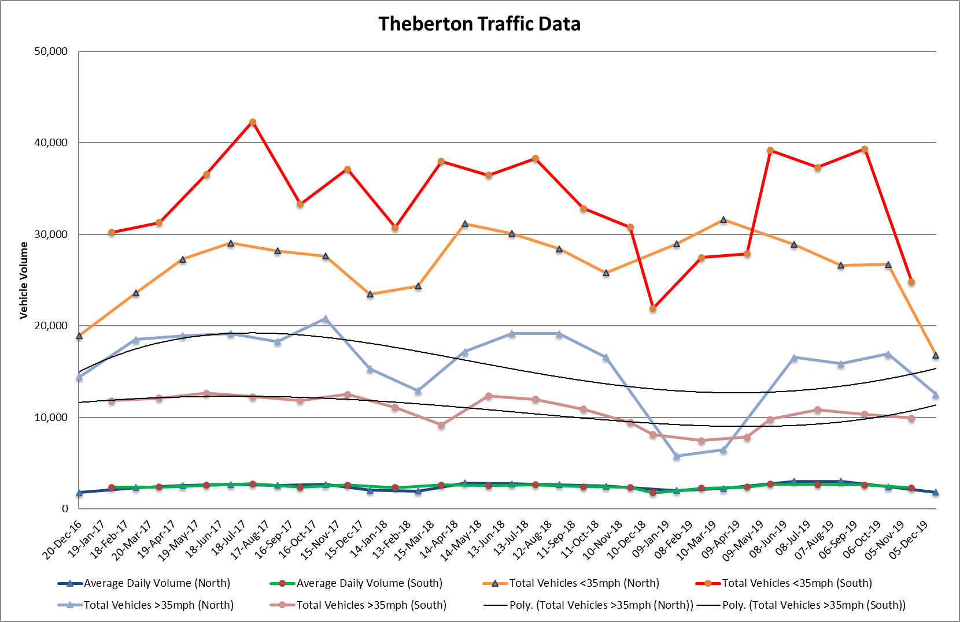



**\*The 85th Percentile is indicative of the speed that the majority of road users are travelling at.**

**Appendix III - Correspondence**

Suffolk Association of Local Councils

a) E-Bulletins - 06/12/19, 20/12/19. b) East Suffolk Forum - 23/01/20 at Darsham.  
c) Buckingham Palace Garden Party 2020 Nomination Form.  
d) Planning Survey - deadline 31/01/20.  
e) Repairs to property relating to the affairs of the church - December NALC Legal Update.

East Suffolk Council

a) Greenprint Forum - Climate Change Event - 03/02/20 at Lowestoft.  
b) Community Partnership Meeting - 27/01/20 at Leiston.  
c) Annual Budget Review Meeting - 14/01/20 at Melton.  
d) Season’s Greetings E-Card.  
e) Community Partnership Website Now Live.  
f) Results of Parliamentary General Election - Suffolk Coastal Constituency.  
g) Committee Management System (CMIS).  
h) District Councillors’ Ward Report Update.

Suffolk County Council

a) Highways - Reply to Report of Blocked Drains at Pretty Road.

Sizewell

a) TASC - Judicial Review Proceedings Against ESC.  
b) SPR - Investment in Skills and Employment.  
c) SPR - East Anglia One North and Two Planning Inspectorate Representations Now Open.  
d) Sizewell A & B Stakeholder Group Meeting - 09/01/20.  
e) EDF Energy - Sizewell B Community Newsletter.

Other

a) PSMA Newsletter - December 2019.  
b) AONB Monthly Update - December 2019.  
c) Suffolk Constabulary - Constable’s County Newsletter.  
d) Email and letter from residents regarding drainage problems on Church Road.