**MINUTES OF THE THEBERTON AND EASTBRIDGE PARISH COUNCIL MEETING HELD   
AT THE JUBILEE HALL, THEBERTON ON WEDNESDAY 10th APRIL 2019 AT 7:30 PM**

1. **Attendance and Apologies**

|  |  |
| --- | --- |
| **Attendees:** Cllr. Stephen Brett - Chair  Cllr. Hilary Ward - Vice-Chair Cllr. Joan Harvey Cllr. Stephen Morphey  Cllr. Graham Bickers Cllr. Paul Collins Cllr. Beth Goose Cllr. Philip Baskett Cllr. Julian Wallis | **Apologies for absence:** County Cllr. Richard Smith  District Cllr. Tony Cooper District Cllr. Susan Geater  **In attendance:**  Sharon Smith - Clerk/RFO |

1. **Declarations of Pecuniary and Non-Pecuniary Interests**

None.

1. **Public Forum**

None.

**4.** **Minutes**

a) It was proposed by Cllr. Hilary Ward, seconded by Cllr. Julian Wallis and agreed that the minutes for the meeting of 13th March 2019 be signed as a true record.

b) It was proposed by Cllr. Hilary Ward, seconded by Cllr. Julian Wallis and agreed that the minutes for the Extraordinary meeting of 28th March 2019 be signed as a true record.

**5. Matters Arising**

None.

**6. Meetings and Progress Reports**

a) Defibrillators - training has been booked for 9th May 2019 and has been communicated to residents via the noticeboards, the newsletter and posters in the pubs. It was agreed the Council will pay for the use of Jubilee Hall. The Council discussed whether to provide the defibrillator cabinet access code to trained residents. It was agreed to seek advice about this from the Community Heartbeat Trust.  
ACTION: Clerk to follow up replacement of faulty heatpad on Eastbridge defibrillator.

b) Grit Bin – an alternative location to the two options already put forward was suggested. A plan showing the location of all three sites needs to be provided to Highways for their consideration and permission.  
ACTION: Cllr. Stephen Brett and Clerk to progress.

c) Police – in January 2019, there were two crimes of violence/sexual offence in Doughty-Wylie Crescent, Theberton which are under investigation and one crime of burglary reported in Chapel Road, Eastbridge. The Council noted that this could actually be the break-in at the Eel’s Foot Inn in December 2018 for which no suspect has been identified. In February 2019, there was one violence/sexual offence crime reported in Chapel Road, Eastbridge which is under investigation.

d) Speed Indicator Device - report attached as **Appendix II**. It was noted that the traffic speed is slightly lower at the Northern end of the village. Cllr. Paul Collins reported that the batteries are losing their longevity and he will alter the settings to try to reduce usage.

e) Sizewell C - report attached as **Appendix III**. The Chairman, on behalf of the Council, thanked TEAGS for their outstanding work and for raising public awareness about the proposals put forward in the Sizewell C consultation.

**7. Administration**

a) The Council conducted the annual review and approval of the Risk Assessment.  
  
b) The Council reviewed the outstanding actions - updated in **Appendix I**.

**8. Finance**

a) The Council noted the latest financial position detailed in **Appendix IV**.

b) The Council reviewed the budgeted versus actual income and expenditure for the financial year 2018/19.

c) The Council agreed to renew the annual Data Protection registration by Direct Debit.

d) It was proposed by Cllr. Stephen Morphey, seconded by Cllr. Beth Goose and agreed to authorise the payments listed below.

|  |  |  |  |
| --- | --- | --- | --- |
| **Details** | **Payee** | **Amount** | **Power** |
| Payroll Services | Suffolk Association of Local Councils | £21.60 | LGA 1972 s.111 |
| Annual Subscription | Suffolk Association of Local Councils | £137.16 | LGA 1972 s.111 |
| Newsletter Printing | Leiston Press | £20.00 | LGA 1972 s.111 |
| Annual Subscription | Sizewell Parishes Liaison Group | £30.00 | LGA 1972 s.111 |
| Annual Subscription | Suffolk Preservation Society | £30.00 | LGA 1972 s.111 |
| Data Protection Registration | Information Commissioner’s Office | £35.00 | LGA 1972 s.111 |
| Insurance – Play Equipment | Business Services at CAS Ltd | £55.63 | LGA 1972 s.111 |

**9. Correspondence**

The Council noted the correspondence received between 8th March 2019 and 4th April 2019 detailed in **Appendix V**.   
  
**10. Questions to the Chair**

a) On behalf of the Council, Cllr. Stephen Brett thanked Cllr. Joan Harvey for her outstanding service both as a Councillor and previously as Clerk. The Council agreed she will be much missed.

b) Cllr. Stephen Morphey asked if there were any plans for the redundant telephone kiosk in Eastbridge. The Chair informed him that the Council chose not to adopt the kiosk as it is not a heritage asset.  
ACTIION: Clerk to contact BT to ask when the kiosk will be removed.

c) Cllr. Hilary Ward informed the Council of matters discussed at the last Hall Management Committee meeting and asked for the Hall Management Committee to be a standing agenda item.

d) Cllr. Graham Bickers asked if members had received a request from East Suffolk Council to submit an Expenses Return Form for the Parish Council election.  
ACTION: Clerk to send Returning Officer’s address to Cllr. Bickers who will circulate this to Councillors with an example completed form.

e) The Council noted that the footpath sign at Back Lane has been knocked down but Highways will not replace it again.

f) The Council noted that the flowers on the site of the Eastbridge village sign have been squashed by a vehicle driving over the green. No suggestions were made to prevent this recurring.

**11. Date and Time of Next Meeting**

The Council confirmed the dates and times of the Annual Parish Meeting and the Annual Meeting of the Council scheduled for Wednesday 8th May 2019 at 7:00 pm and 8:00 pm respectively.

The meeting closed at 8:55 pm.

**Appendix I - Outstanding Actions**

|  |  |  |  |  |
| --- | --- | --- | --- | --- |
| **Meeting Date** | **Item Ref** | **Action** | **Responsibility** | **Comments** |
| 11/01/17 | 5a | Ascertain quantity of documentation to be stored and obtain quote from Sizewell Storage. | Clerk/Cllr. Joan Harvey/Cllr. Beth Goose | 06/02/18 - to form part of the GDPR review. 10/04/19 - Cllr. Harvey to continue rationalising paper records and will liaise with the Clerk. Cllr. Goose to obtain quote. |
| 06/09/17 08/11/17 | 5b 7c | Send SID data to SCC Highways and request a visit from the speed camera unit. | Cllr. Stephen Brett/Clerk | 10/04/19 – Cllr. Brett to speak to County Cllr. Richard Smith. |
| 06/09/17 | 5g | Order two playpark ownership signs. | Clerk. | 13/06/18 - updated under item 10b. 10/04/19 – Clerk to progress. |
| 06/09/17 | 6e | Ascertain whether a litter bin can be placed on Highways land, whether Suffolk Norse will empty it and whether the sign can be renewed at the Theberton layby. | Cllr. Hilary Ward/Clerk | 13/06/18 - updated under item 5c. 10/04/19 – Cllr. Ward to speak to Suffolk Coastal Norse. |
| 08/11/17 | 10a | Purchase work party tools to the value of £515. | Cllr. Stephen Brett | 10/04/19 – Cllr. Brett to progress. |
| 08/11/17 | 12a | Draft an emergency plan and add to a future agenda for approval and also consideration of the provision of grit bins. | Clerk/Cllr. Beth Goose | 29/11/18 - grit bin requested from County Cllr. Richard Smith. 10/04/19 – Clerk to send draft emergency plan to Cllr. Goose to progress. |
| 10/01/18 | 5a | Install gate at Theberton play area. | Cllr. Stephen Brett/Cllr. Graham Bickers | 29/11/18 - posts installed. 10/04/19 – waiting for trees by proposed gate site to be removed by a resident. |
| 15/08/18 | 5c | Apply to Outdoor Play Scheme Fund for a grant to replace slide and provide a climbing frame at Theberton play area. | Cllr. Hilary Ward | 10/04/19 – to be added to next month’s agenda. Cllr. Ward to begin researching ideas. |
| 09/01/19 | 8c | Establish a sinking fund to cover the cost of repairs and replacement of play equipment. Remove old play equipment. | Cllr. Paul Collins | Waiting for information from Sovereign. 10/04/19 – Cllr. Collins to progress. |
| 13/02/19 | 8c | Register the Eel’s Foot Inn as an Asset of Community Value. | Clerk | 10/04/19 – Clerk to progress. |
| 13/03/19 | 3 | To discuss the proposal to impose a speed limit in Eastbridge with an SCC Highways engineer. | Cllr. Stephen Brett | Waiting for contact details from County Cllr. Richard Smith. |

**Appendix II - Speed Indicator Device**

The speed indicator device has been operational for twenty-six ~20 day periods since 20th December 2016. It is placed at one end of the village or other at ~30 day intervals.

For the last 2 months the SID was placed at the each end of the village but turned around to watch the traffic leaving the village. There is a drop in number of vehicle movements but that may be due to the SID being confused when traffic is going in both directions. So whilst the vehicle movements data may be low, the more interesting statistics are that the percentage exceeding 35mph has decreased to 16.7% and 21.4% and the 85 percentile speed* is 35.7mph and 37.1mph compared to 40.7mph and 38.6mph when they enter the village showing that vehicles are slowing down further as they pass through the village.

A second set of values will be obtained over the next two periods and if this persists, the SID will be reversed again to detect vehicles as they enter the village.

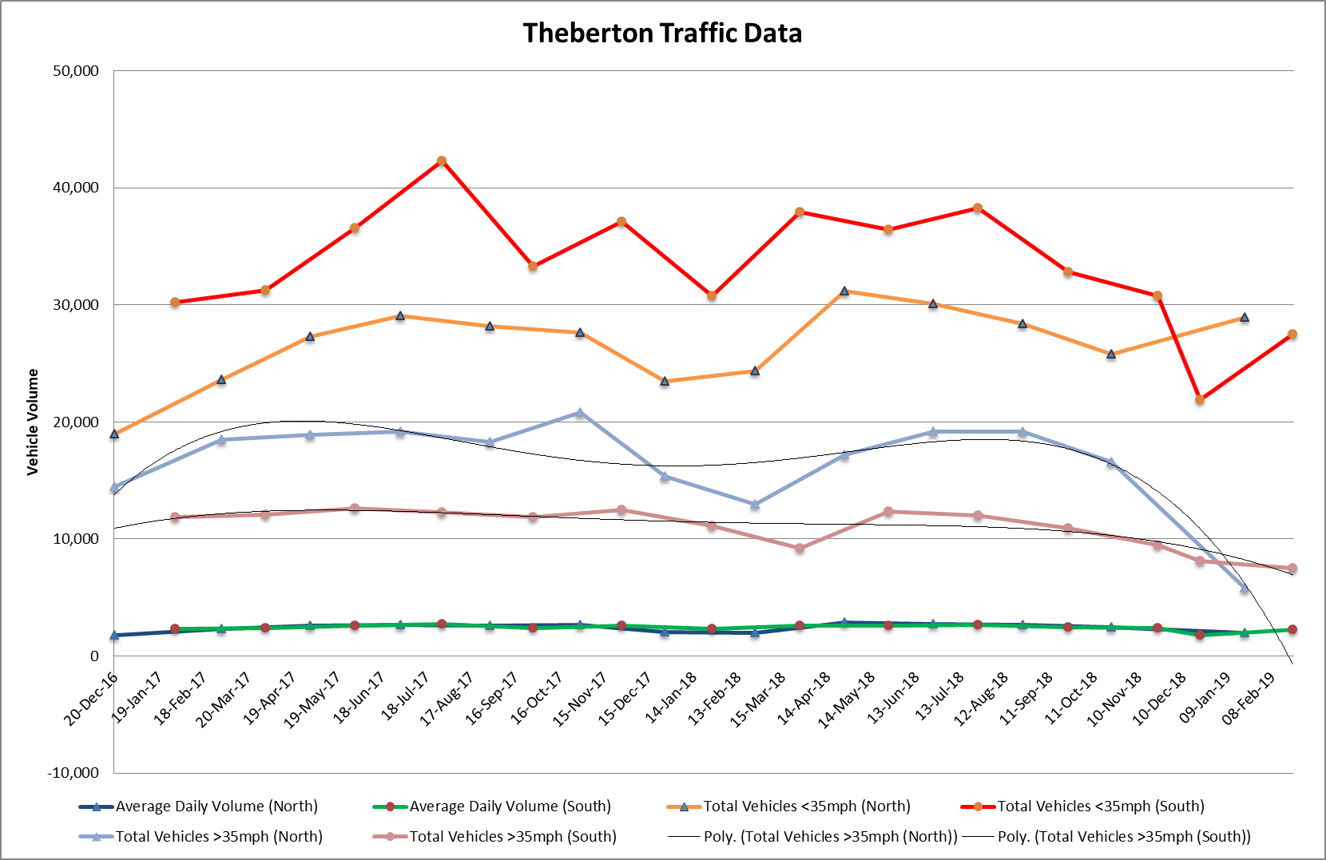



**\*The 85th Percentile is indicative of the speed that the majority of road users are travelling at.**

**Appendix III - Sizewell C Report**

**1 TEAGS**

The majority of the time in the second half of March was bringing together the response which combined information from both Minsmere Levels Stakeholders Group and B1122 Group along with our own assessment of campus and people impacts in the parish and wider aspects concerning job creation etc.

The final response was submitted with Theberton and Eastbridge PC, Middleton PC, SPLG, B1122 and MLSG responses on Friday 29th March at the EDF Leiston Office.

We are also now meeting with the combined wind farm groups as Anglian Energy Planning Alliance to see how their efforts and our own on SZC overlap and could benefit our overall efforts.

The next steering meetings isn’t scheduled but we are also looking for a date for our AGM which will probably be in June.

**2 Theberton and Eastbridge Parish Council Sizewell C Efforts**

**SZC Sustainability Analysis**

On-going. The changes to the operational car parking and training/visitor centre for SZC, the reduction to three borrow pits and the move of SZB facilities to Coronation Wood need to be taken into account. Further references to analyses of this type have been provided by contacts at RSPB.

**3 SPLG 7:30pm, 22nd March – Theberton Village Hall**

SPLG had a copy of our draft response and compiled a response on behalf of Middleton, Kelsale-cum-Carlton, Wenhaston, Walberswick and Theberton and Eastbridge parishes. A draft wasn’t circulated until before being submitted on 29th March at the EDF Leiston Office. The final version is attached for information.

**4 Other**

We are still seeking another meeting with the BLUECoast team as soon as possible.

**Appendix IV - Financial Position**

|  |  |
| --- | --- |
| **Bank Balances as at 14th March 2019** |  |
| Barclays Current Account | £4,349.64 |
| Barclays Savings Account | £1,513.77 |
|  | **£5,863.41** |
|  |  |
| **General and Earmarked Reserves** |  |
| EDF Energy Grant - Work Party Tools | £515.00 |
| Earmarked - Eastbridge Common Legal Costs | £600.00 |
| General Reserves | £2,495.00 |
|  | **£3,610.00** |
|  |  |
| **Bank Balance less Reserves** | **£2,253.41** |
|  |  |
| **Payments - April 2019** |  |
| SALC - Payroll Services | £21.60 |
| Suffolk Preservation Society - Annual Subscription | £30.00 |
| ICO - Data Protection Registration | £35.00 |
| Leiston Press - Newsletter Printing | £20.00 |
| SPLG - Annual Subscription | £30.00 |
|  | **£136.60** |
|  |  |
| **Net Balance** | **£2,116.81** |

**Appendix V - Correspondence**  
Suffolk Association of Local Councils

a) NALC Legal Briefing - March 2019.  
b) Suffolk Coastal Area Forum.  
c) New website and login details.  
d) Greenprint Forum Steering Group.

District Council and County Council

a) SCDC - Notice of Elections.  
b) SCDC - East Suffolk Council creation on 1 April 2019.  
c) SCDC - Submission of Suffolk Coastal Local Plan to Planning Inspectorate.  
d) SCDC - Copy of response to complaint from a resident of Eastbridge Common.   
e) SCC - Emergency Drainage Works on B1119

Suffolk Constabulary

a) Safer Neighbourhood Team Newsletter - March 2019.  
b) Annual Crime Figures.

Energy Companies  
  
a) SPLG - minutes.  
b) SPLG - Sizewell C consultation submission.  
c) Planning Aid England - evaluation of support for Sizewell C consultation.  
d) Eastbridge resident - Sizewell C consultation submission.  
e) MLSG - Sizewell C consultation submission.  
f) EDF Energy - Sizewell B Community Newsletter.

Other

a) Keep Britain Tidy - Great British Spring Clean.  
b) Yox Valley Schools - Governor Recruitment.  
c) AONB - Monthly Update.  
d) Six emails from a resident of Eastbridge Common.